1. Browse to the [official Jenkins download page](https://www.jenkins.io/download/). Under the **Downloading Jenkins** section is a list of installers for the long-term support (LTS) version of Jenkins. Click the **Windows** link to begin the download.

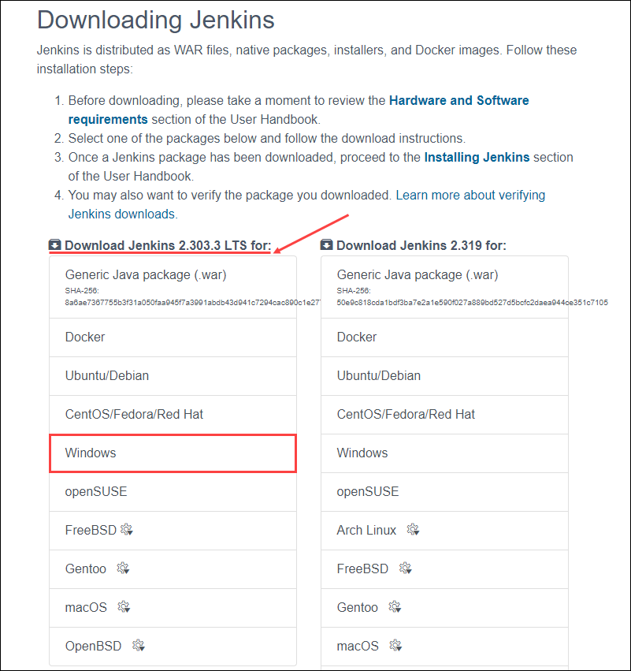

1. Once the download is complete, run the **jenkins.msi** installation file.

**java –jar jenkins.war or** java -jar jenkins.war --httpPort=8089

* It will list all the plugins required for continuous integration server
* It will give you an initial admin password and location of the password also.
* Now the server is up and running
* By default it runs in port: 8080

Incase if you have downloaded the installer then follow below process

3. The setup wizard starts. Click **Next** to proceed.

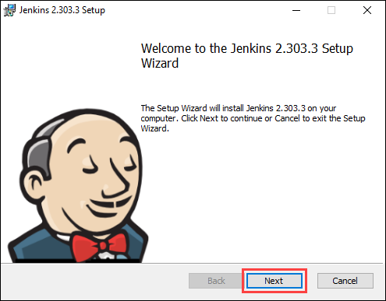

4. Select the install destination folder and click **Next** to continue.

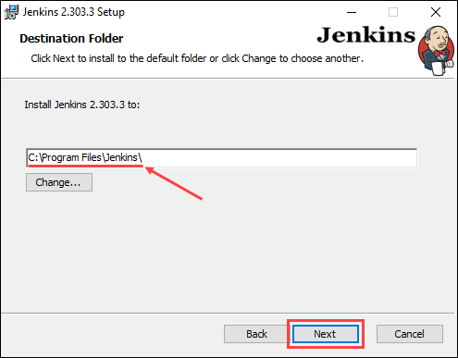

5. Under the **Run service as a local or domain user** option, enter the domain username and password for the user account you want to run Jenkins with. Click **Test Credentials** to verify the login data, then click **Next** to proceed.

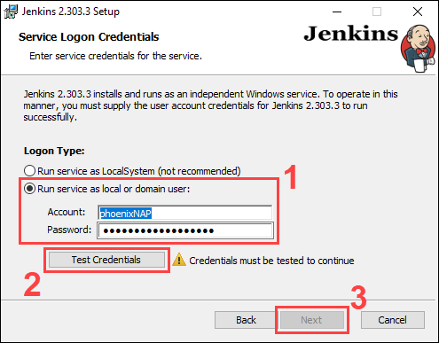

6. Enter the port number you want Jenkins to run on. Click **Test Port** to check if the selected port is available, then click **Next** to continue.

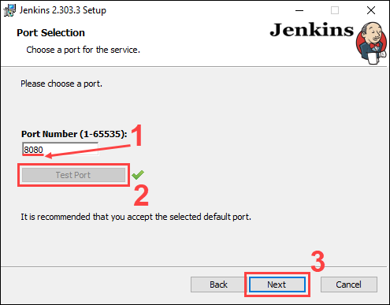

7. Select the directory where [Java is installed](https://phoenixnap.com/kb/check-java-version-on-mac-windows) on your system and click **Next** to proceed.

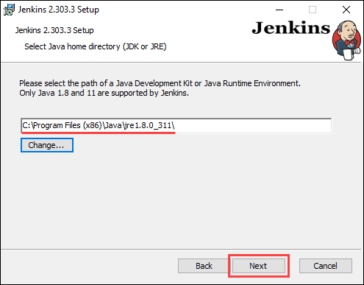

8. Select the features you want to install with Jenkins and click **Next** to continue.

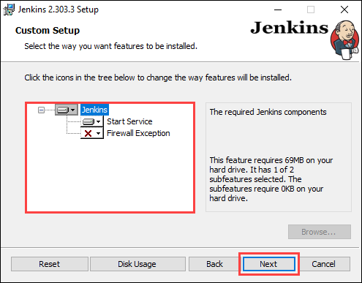

9. Click **Install** to start the installation process.

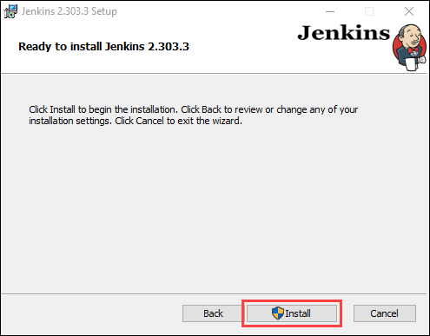

10. Once the installation is complete, click **Finish** to exit the install wizard.

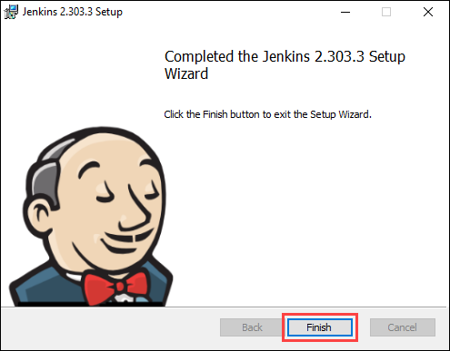

**Unlocking Jenkins**

1. In your web browser, navigate to the port number you selected during the installation using the following address:

http://localhost:[port number]

2. Navigate to the location on your system specified by the Unblock Jenkins page.

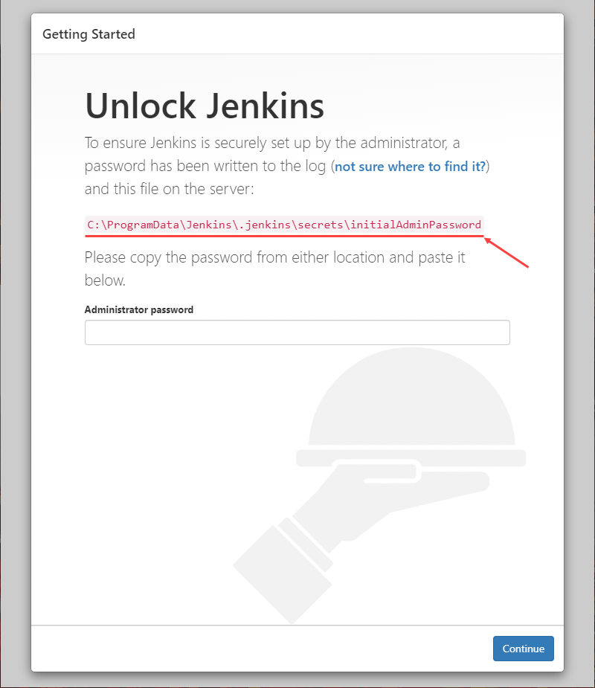

3. Open the **initialAdminPassword** file using a text editor such as Notepad.

4. Copy the password from the **initialAdminPassword** file.

5. Paste the password in the **Administrator password** field on the Unblock Jenkins page and click **Continue** to proceed.

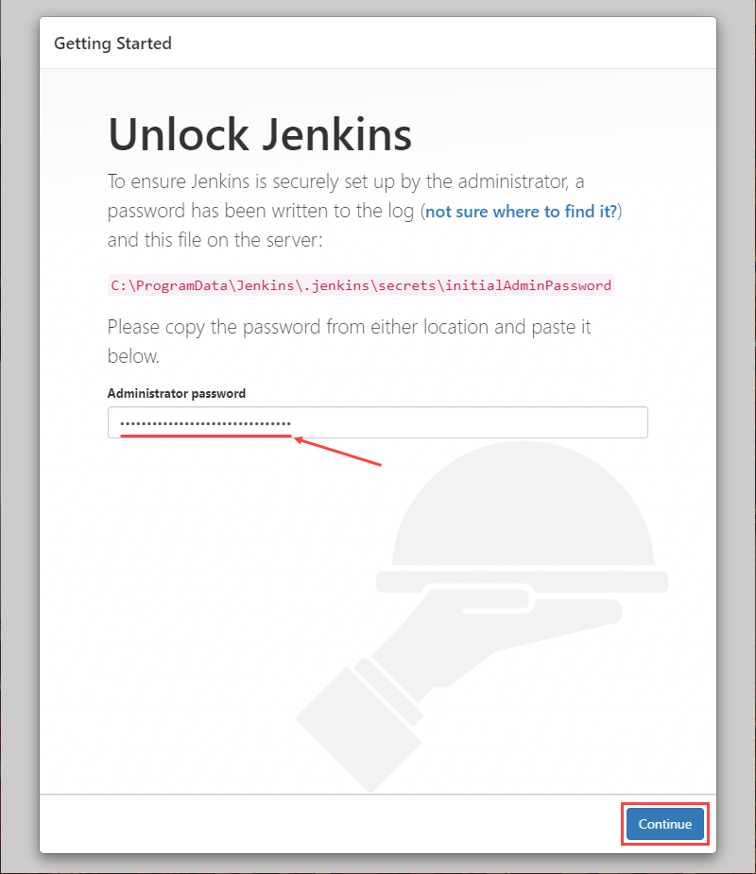

**Customizing Jenkins**

1. Click the **Install suggested plugins** button to have Jenkins automatically install the most frequently used plugins.

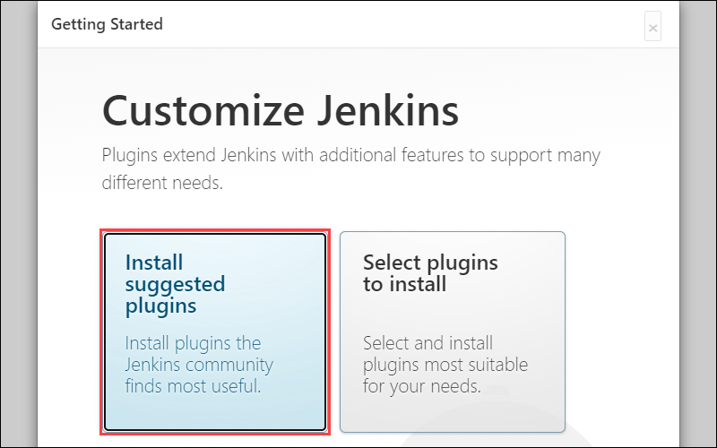

2. After Jenkins finishes installing the plugins, enter the required information on the **Create First Admin User** page. Click **Save and Continue** to proceed.

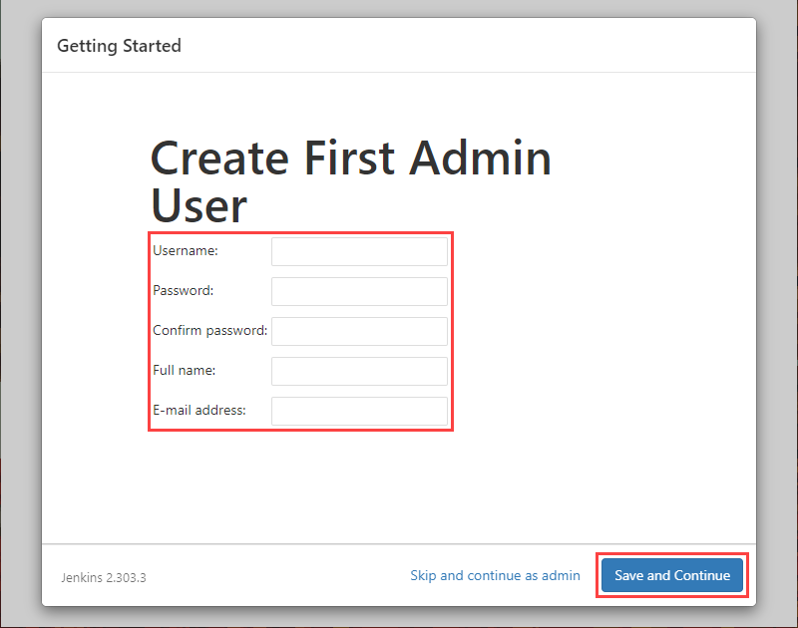

3. On the **Instance Configuration** page, confirm the port number you want Jenkins to use and click **Save and Finish** to finish the initial customization.

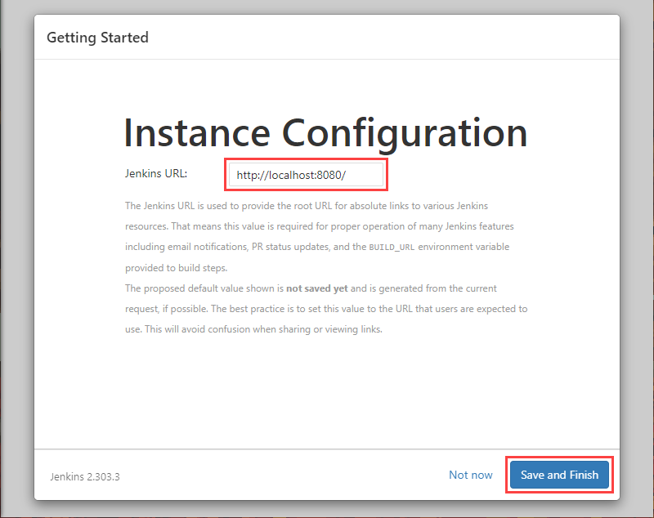

4. Click the **Start using Jenkins** button to move to the Jenkins dashboard.

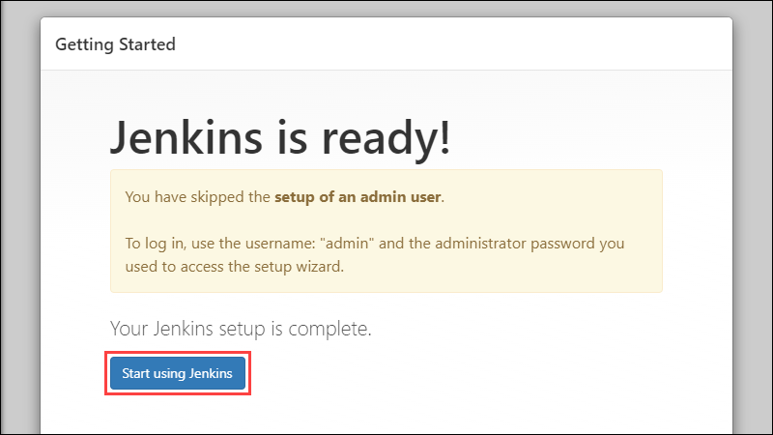

5. Using the Jenkins dashboard, click **Create a job** to [build your first Jenkins software project](https://phoenixnap.com/kb/jenkins-build-freestyle-project).

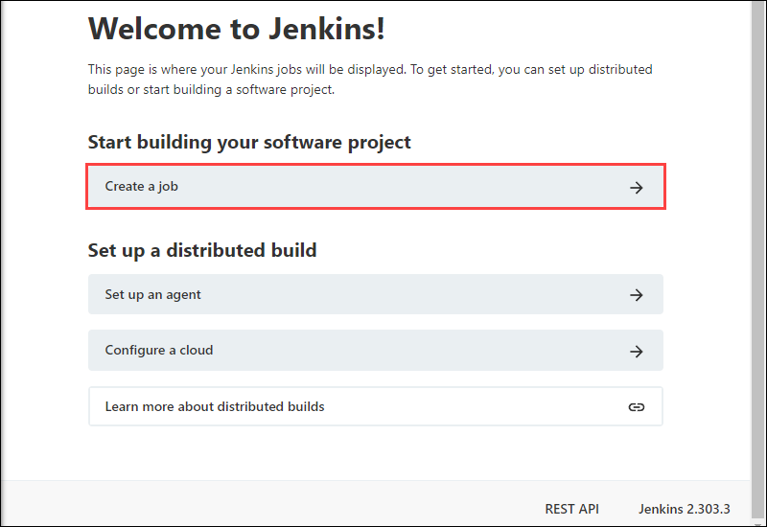

Once installed, Jenkins allows you to either accept the default plugin list or choose your own plugins.

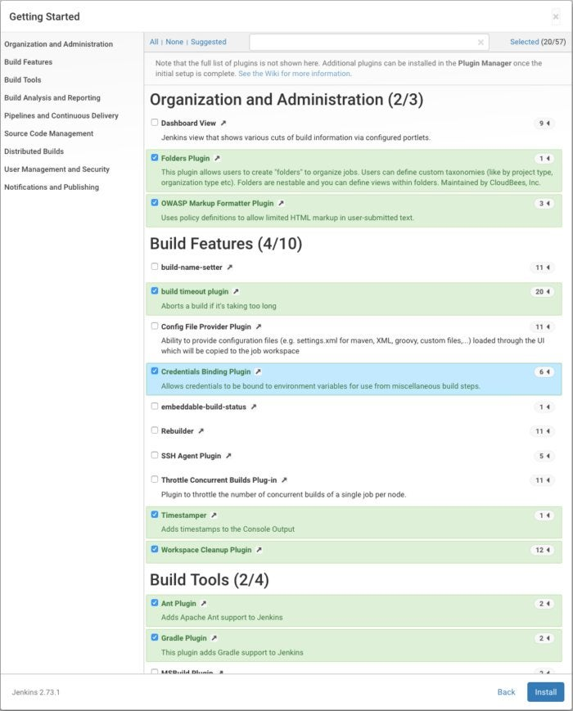

Once you have picked your initial set of plug-ins, click the Install button and Jenkins will add them.

The Jenkins main screen displays the current build queue and Executor status, and offers links to create new items (jobs), manage users, view build histories, manage Jenkins, look at your custom views, and manage your credentials.

